Question:
Fit a curve of the form y = a + bx using the Least Squares Method in Python.
Aim:
Write a Python program to demonstrate to fit a straight-line curve (y = a + bx) using the least squares method.
Program:
# Curve Fitting — Straight Line (fully fixed)
from typing import List, Tuple

def fit_line(x_values: List[float], y_values: List[float]) -> Tuple[float, float]:
"""Return (a0, a1) for best fit line y = a0 + a1*x using least squares."""
if len(x_values) != len(y_values) or len(x_values) == 0:
raise ValueError("x_values and y_values must have same non-zero length.")

n = len(x_values)
sum_x = sum(x_values)
sum_y = sum(y_values)
sum_x2 = sum(x * x for x in x_values)
sum_xy = sum(x * y for x, y in zip(x_values, y_values))

denom = n * sum_x2 - sum_x * sum_x
if abs(denom) < 1e-12:
raise ValueError("Denominator nearly zero: can't compute unique fit (collinear x?).")

a1 = (n * sum_xy - sum_x * sum_y) / denom
a0 = (sum_y - a1 * sum_x) / n
return a0, a1

def print_table(x_values: List[float], y_values: List[float]) -> None:
n = len(x_values)
rows = []
for x, y in zip(x_values, y_values):
rows.append((x, y, x * x, x * y))

widths = [10, 10, 12, 12]
header = f"{'x':>{widths[0]}}{'y':>{widths[1]}}{'x^2':>{widths[2]}}{'x*y':>{widths[3]}}"
print(header)
print("-" * (sum(widths)))

for r in rows:
print(f"{r[0]:{widths[0]}.4f}{r[1]:{widths[1]}.4f}{r[2]:{widths[2]}.4f}{r[3]:{widths[3]}.4f}")

sum_x = sum(r[0] for r in rows)
sum_y = sum(r[1] for r in rows)
sum_x2 = sum(r[2] for r in rows)
sum_xy = sum(r[3] for r in rows)

print("-" * (sum(widths)))
# Fixed formatting: text and numbers formatted separately
print(f"Σx = {sum_x:.4f}\tΣy = {sum_y:.4f}\tΣx² = {sum_x2:.4f}\tΣxy = {sum_xy:.4f}\n")

def predict(a0: float, a1: float, x: float) -> float:
return a0 + a1 * x

def interactive():
print("Curve fitting (straight line) — enter data points.")
try:
n = int(input("How many points? "))
except ValueError:
print("Invalid number of points.")
return

if n <= 1:
print("Need at least two points.")
return

x_values = []
y_values = []
for i in range(n):
raw = input(f"Point {i+1} as 'x y' (e.g. 2 5): ").strip().split()
if len(raw) < 2:
print("Invalid input, try again.")
return
try:
x_values.append(float(raw[0]))
y_values.append(float(raw[1]))
except ValueError:
print("Invalid numeric input.")
return

print()
print_table(x_values, y_values)
try:
a0, a1 = fit_line(x_values, y_values)
except ValueError as e:
print("Error:", e)
return
print(f"Best fit line: y = ({a0:.6f}) + ({a1:.6f}) x")

choice = input("Predict y for some x? (y/n): ").strip().lower()
if choice == "y":
try:
xv = float(input("Enter x: "))
print(f"For x = {xv}, predicted y = {predict(a0, a1, xv):.6f}")
except ValueError:
print("Invalid x value.")

if __name__ == "__main__":
# Example usage (uncomment interactive() to use interactive input)
# interactive()

# Example data (will print table and fitted line)
x_values = [0, 2, 5, 7]
y_values = [-1, 5, 12, 20]

print_table(x_values, y_values)
a0, a1 = fit_line(x_values, y_values)
print(f"Best fit line: y = ({a0:.6f}) + ({a1:.6f}) x")
print(f"For x = 8, predicted y = {predict(a0, a1, 8):.6f}")
Result:
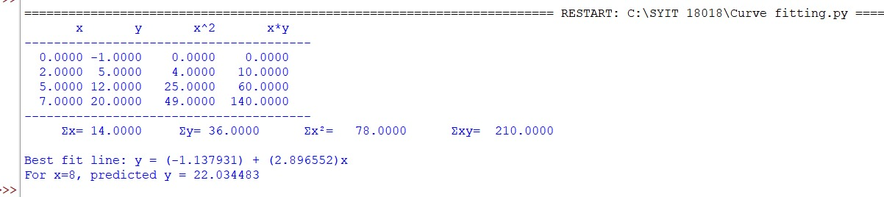
Conclusion:
The above Python program has been executed successfully.

